Ricotta Gnocchetti (Tuscany)

[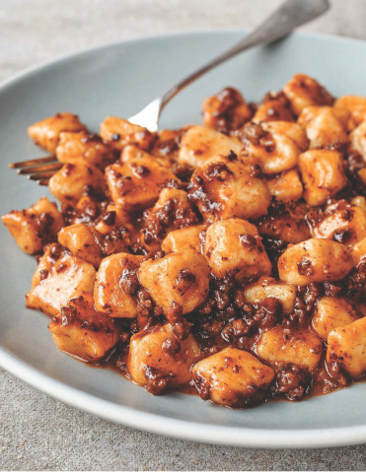](https://coolfooddudedotcom.files.wordpress.com/2015/06/img_7753.jpg)

*Photo by Ed Anderson*

Serves 6

These gnocchetti are soft, tender, and rich with ricotta. In the fall, I dress them with sautéed squash and sage brown butter. In the winter, I serve them with a meat ragù. In the summer, it must be pesto!

480 G/2 CUPS WHOLE-MILK RICOTTA CHEESE, HOMEMADE (recipe follows) OR STORE-BOUGHT

25 G/¼ CUP FINELY GRATED PARMIGIANO-REGGIANO CHEESE

1 EGG

1 TBSP UNSALTED BUTTER, MELTED

FRESHLY GRATED NUTMEG

125 G/¾ CUP + 2 TBSP ALL-PURPOSE FL OUR, PLUS MORE FOR DUSTING

SEMOLINA FLOUR FOR DUSTING

In a large bowl, combine the ricotta cheese, Parmigiano-Reggiano cheese, egg, melted butter, and a few swipes of nutmeg. Add the all-purpose flour and mix with your hands just until combined. The dough should be slightly sticky and wet. Do not overmix, as this will make the gnocchetti tough.

Dust 30 g/¼ cup all-purpose flour on the work surface, then scrape the dough from the bowl directly on top of the flour. Sprinkle the top of the dough with an additional 30 g/ ¼ cup all-purpose flour. This will help prevent the dough from being too sticky to roll.

Line two baking sheets with parchment paper and dust with semolina flour. Cut off a chunk of dough, about 25 g/¼ cup, and cover the rest with plastic wrap. On a work surface lightly dusted with all-purpose flour, use your hands to roll the chunk into a log about ¼ in (6 mm) in diameter. Cut the log into ½-in (12-mm) pieces. Put the gnocchetti on the prepared baking sheets and shape the remaining dough. Make sure that the gnocchetti don’t touch or they will stick together.

(To store, refrigerate on the baking sheets, covered with plastic wrap, for up to 2 days, or freeze on the baking sheets and transfer to an airtight container. Use within 1 month. Do not thaw before cooking.)

Bring a large pot filled with generously salted water to a simmer over medium-high heat. Add the gnocchetti and simmer until they float to the surface, 1 to 3 minutes. Remove immediately with a slotted spoon and finish with your choice of sauce. Serve right away.

HOMEMADE RICOTTA

Makes 2 lb (900 g)

Homemade ricotta is splendid. Making fresh cheese is much easier than you might think, and the end result is creamier and richer than most store-bought ricottas. This recipe is made with mostly whole milk and buttermilk, but contains some half-and-half, too. The end result is rich in texture and flavor, but not overwhelmingly rich like a cream-based cheese. The by-product, whey, is wonderful—don’t throw it away! It will keep for about 1 week, refrigerated, and is great in dishes when you want a lactic and acidic flavor. My favorite uses include whey-braised pork (instead of milk-braised) and wilting spinach with whey and preserved lemon.

5 QT (4.7 L) WHOLE MILK

5 CUPS (1.2 L) BUTTERMILK

3 CUPS (720 ML) HALF-AND-HALF

Combine the milk, buttermilk, and half-and-half in a large, heavy-bottomed pot and cook over high heat, stirring gently every few minutes to distribute the heat evenly, for 6 to 8 minutes. When curds start to form, stop stirring. Bring the mixture to 175°F (80°C), as measured on an instant-read thermometer, then turn off the heat and let cool, without disturbing, until the mixture is almost at room temperature. Carefully transfer the pot to the refrigerator and let cool completely.

Meanwhile, line a large fine-mesh strainer with a double layer of cheesecloth and set the strainer over a large, deep bowl so that the whey can drain. When fully cooled, remove the pot from the refrigerator and gently ladle the curds into the strainer. Cover with plastic wrap, refrigerate, and let drain overnight.

The following day, transfer the ricotta to airtight containers. Seal tightly and refrigerate for up to 1 week. Do not freeze ricotta.

Pair with the sauce of your choice.

*Recipe reprinted with permission from Pasta by Hand, by Jenn Louis, Raincoast Books*